Languages Department
2021 External Schools Handbook

School Contact Details

 | Emerald Campus  eKindy - Year 6 | Rockhampton Campus  eKindy - Year 12
Office Hours | Monday to Friday 8:00am to 4:00pm | Monday to Friday 8:00am to 4:00pm
Teaching Hours | Monday to Friday 8:45am to 3:00pm | Monday to Friday 8:45am to 3:00pm
Location | Gladstone and Gray Street Emerald Qld 4720 | 241-259 Farm Street  Kawana Qld 4701
Telephone | (07) 4987 9100 | (07) 4931 4800
Facsimile | Fax: (07) 4987 4156 | (07) 4926 2435
Postal Address | PO Box 1616  Emerald Qld 4700 | 241 – 259 Farm Street  Kawana Qld 4701
Email | the.principal@capricorniasde.eq.edu.au
Facebook | www.facebook.com/capricornia.sde
Twitter | www.twitter.com/CapricorniaSDE
Website | www.capricorniasde.eq.edu.au
Languages Email | LOTE@capricorniasde.eq.edu.au

Languages Staff Contact Details

Name | Phone | Email
Georgina Harch (Deputy) | 49 314 855 | gharc3@eq.edu.au
Stacey Stewart (HOD) (P-2 Coordinator) | 49 314 819 | sstew107@eq.edu.au
Caroline Meakin (3-4 Coordinator) | 49 314 878 | cmeak5@eq.edu.au
Miho Davis (5-6 Coordinator) | 49 201 626 | mxdav15@eq.edu.au
Kylie Huff (7-8 Coordinator) | 49 314 818 | khuff2@eq.edu.au
Yuko Smith (9-12 Coordinator) | 49 314 892 | yxsmi0@eq.edu.au
Alice Edwards | 49 314 857 | aedwa57@eq.edu.au
Brooke Lindley | 49 314 615 | belin0@eq.edu.au
Cassie Yoshimi | 49 314 664 | cxyos0@eq.edu.au
Claire Sellens | 49 314 817 | clsel0@eq.edu.au
Dean Smith (Teacher Aide) | 49 314 669 | dsmit577@eq.edu.au
Donna Sims | 49 314803 | dsims5@eq.edu.au
Douglas Rutherford | 49 314 859 | druth13@eq.edu.au
Erin Rogers | 49 314 662 | emeva0@eq.edu.au
Murray Harch | 49 314 857 | mharc4@eq.edu.au
Natalie Wilkes | 49 314 857 | nwilk45@eq.edu.au
Nikki Hall | 49 314 837 | nhall106@eq.edu.au
Odette Tuitama-Roberts | 49 314 625 | obrob0@eq.edu.au
Robyn McRae Zurvis | 49 314 643 | rmcra5@eq.edu.au
Shelley Beasley | 49 879 117 | sbeas8@eq.edu.au
Shiho Britos | 49 201 636 | snaka18@eq.edu.au
Tegan Kelloway | 49 314 638 | tekel0@eq.edu.au
Yasuyuki Shimizu | 49 314 658 | yxshi1@eq.edu.au
Zteven Whitty | 49 314 838 | zjwhi0@eq.edu.au

Languages Philosophy

The study of Languages at CSDE is designed to enable all students to learn a language in addition to English. Languages recognises that students bring their own linguistic and cultural background to their learning, whether this is English, Japanese or various combinations of other languages. At CSDE, we provide this for students that have had previous Japanese language experience; as well as a support for students without previous Japanese language experience. The curriculum addresses learner backgrounds in Japanese by providing a number of pathways and entry points of study to cater for the diversity and background of our language learners.

The CSDE Languages Department comprises of highly trained and professional teachers who are passionate about Japanese pedagogy and culture. The Languages Department delivers quality, engaging online Japanese lessons to over two thousand students across Queensland from Prep to Year 12 using programs that align to ACARA.

CSDE 2021 Timetable Hours

LESSON BLOCKS | TIMES
Morning Session 1 | 8:30am – 9:00am
Period 1 | 9:00am – 9:35am  9:35am – 10:10am
5 minute change over | 10:10am – 10:15am
Period 2 | 10:15am – 10:50am  10:50am – 11:25am
Lunch (45 minutes) | 11:25am – 12:10pm
Period 3 | 12:10pm – 12:45pm  12:45pm – 1:20pm
Afternoon Tea (30 minutes) | 1:20pm – 1:50pm
Period 4 | 1:50pm – 2:25pm  2:25pm – 3:00pm

Lessons Offered

YEAR LEVEL | TIMES
Prep - 2 | 1 x 30 minute Japanese lesson (P-1)  1 x 45 minute Japanese lesson (2)
Year 3 - 6 | 2 x 45 minute Japanese lessons  or 1 x 60 minute Japanese lesson
Year 7 and 8 | 2 x 70 minute Japanese lesson (C2C)  1 x 70 minute Japanese lesson (C2C entry)
Year 9 | 2 x 70 minute Japanese lessons
Year 10 | 3 x 70 minute Japanese lessons
Year 11 | 3 x 70 minute Japanese lessons
Year 12 | 3 x 70 minute Japanese lessons

- Whilst we recommend these times, we understand that they may not suit some external school timetables. If you need to negotiate lesson length, please contact Georgina Harch.

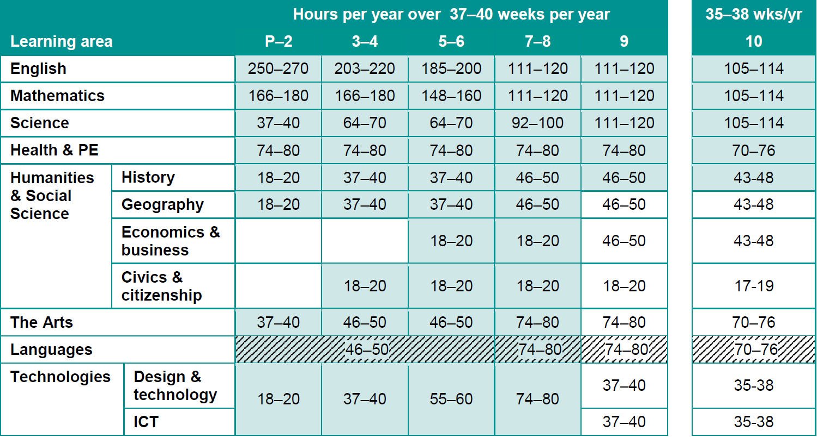

Mandatory Years

The study of a language is mandatory for all students in Year Five to Year Eight at all Education Queensland Schools. It, however, is recommended to be taught from Prep.

Language being taught:

- Japanese

No lessons taught:

- Term 1 – All of Week 1 and Thursday of Week 10
- Term 2 – Week 10 – Friday
- Term 3 – Week 10 - Friday
- Term 4 – Week 9 – Thursday & Friday
- Term 4 – Week 10

What to expect from the CSDE teacher

Curriculum

- At CSDE our program is delivered in line with the Australian Curriculum.
- Curriculum plans (unit overviews) will be sent by our teachers at the start of each term.
- Our HOD will provide school administration with copies of assessment and year level band plans at the start of each year.

Teacher absences

- If a CSDE teacher is absent, we will endeavour to cover classes with a replacement teacher. Due to the short supply of teachers, however, this cannot always be guaranteed. Schools will be notified in the morning if classes will need to be cancelled due to teacher absence. Our teachers will send work through if possible.
- Planned absences – if your teachers have absences in advance they will negotiate a time to reschedule lessons if possible.

Resources

- Any booklets or materials required for lessons will be printed by CSDE and sent to school. Only in urgent situations will teachers occasionally require the external school to print something off.
- Each school will be provided with an engagement kit. This will contain items such as origami paper, reward stickers, script charts and other useful resources that teachers can utilize during lessons. We ask that the engagement kit be kept in a room that is accessible to all classes (such as computer room, office, teacher aide room). These will be returned to CSDE at the end of each year for restocking and updating.
- Prizes and certificates will be sent to selected students during the year.
School Visits

- Our teachers love to visit our external school when they are able to. Whilst not all of our schools may receive a face to face visit, we do try to do as many road trips as possible. We will negotiate times of visits with schools. If you have any particular special dates that you think would be preferable for us to visit, please let us know.

Inductions

- An induction session with all of the supervising teachers and relevant staff, and
- An induction lesson with all of the students.

Communication

- Regular communication from the CSDE teacher, and check-ins from the HOD & Deputy.
- CSDE teachers will firstly contact the classroom teacher to discuss any students of concern. Should there continue to be behaviour or engagement issues, than the CSDE teacher will make contact with the parent/guardian and record the conversation on One School.

Lessons

- Engaging online Japanese lessons.
- A high standard of expectations.
- Evidence of student work captured in lessons.
- Differentiation strategies used to cater for all students.
- Booklets will be provided for each unit.

Assessment

- Assessment will be completed by the CSDE teacher during lessons. If, however, a student is absent, the CSDE teacher may suggest other options.

Reporting

- Personalised Learning Plans recorded on One School for students requiring extra support.
- Our teachers will complete reports through the External School One School system by their due dates.
- Reports will be written using the CSDE Reporting Guidelines.

Feedback

- Regular feedback provided to the students during lessons.
- Verbal feedback provided to students after assessment.
- A snip of student results from One School Mark Book will be provided after each assessment.
- GTMJs available on request.

EXTERNAL SCHOOL REQUIREMENTS

Internet

It is recommended that your school has an internet speed of at least 10mbps for Japanese lessons to work effectively. To check your internet capacity, please contact Service Centre Online before enrolling. If the bandwidth is not at this speed, a bandwidth upgrade may need to be considered. The Regional Technology Officer may also provide support and advice.

The Learning Place also has 10 tips to help with internet connectivity.
https://staff.learningplace.eq.edu.au/help-centre/web-conferencing/troubleshooting/Pages/top-ten-tips.aspx#01

Resources

Prep – Year 2

- An Interactive Whiteboard
- A portable microphone/speaker (We recommend the Jabra Speak510 + UC BT Speakerphone including Link360 USB Dongle)
- A class set of whiteboards
- A class set of whiteboard markers

Year 3 – Year 10

- A computer per student
- A headset with a microphone
- A Japanese notebook (64 page A4)
- A pencil and eraser
- Access to an Interactive Whiteboard
- Access to a portable microphone/speaker (We recommend the Jabra Speak510 + UC BT Speakerphone including Link360 USB Dongle)

External School Supervisor Requirements

Every class needs to have a supervisor. The ESS will be required to:

Induction

- Attend an induction session with the CSDE teacher before lessons commence.

Communication

- Communicate regularly with the CSDE teacher.
- Inform the CSDE teacher of any interruptions to Japanese lessons during the term, for example, carnivals.
- Inform the CSDE teacher when a new student arrives and provide them with the student’s full name, MIS ID and EQ ID.
- Inform the CSDE teacher when a student has left your school.
- Join our CSDE Facebook page.
- Make our teachers aware of your school’s behaviour management system and any relevant processes to follow.

Lessons

- Supervising teacher/aide to log into every lesson.
- Be responsible for behaviour management in the classroom.
- Support students to log in on time.
- Be prepared to print out or scan documents for us, if necessary.

Assessment

- Be prepared to support the CSDE teacher to catch up students who may be absent for assessment. This may mean alternative ways of capturing evidence, for example, voice recordings.
- Be prepared to scan assessment tasks and email them to us, if necessary.

Reporting

- Assist the CSDE teacher with effort and behaviour comments on report cards as this is often difficult to gauge over the computer.

External School Administration Requirements

- Grant access to your One School for the CSDE teacher.
- Set up reports in One School and add the CSDE teacher.
- Reporting timeline (dates reporting period open and due dates) to be communicated on CSDE teacher in advance.
- Ensure that extra-curricular lessons don’t clash with Japanese lessons.
- Record student exemptions on One School. Exemptions are to be documented in the Student Plan section of One School as a Personalised Learning Record.
- Edit report card comments to suit your reporting guidelines.
- If the ESS is away, notify CSDE with the name of the replacement ESS teacher and assist them with accessing the lesson.

Computer Programs

The Learning Place

Our lessons are accessed via Blackboard Collaborate through the Learning Place. If you have an issue with accessing lessons, please contact The Learning Place on:

E: learningplace@qed.qld.gov.au
T: 1800 680 445 (follow the prompts)

Windows 10 – S Mode

If you are using Windows 10, you will need to disable the S Mode for our lessons to work. Please contact us if you need instruction on how to do this.

Enrolment Process

- Complete the School Based Class Group Enrolment Form
https://capricorniasde.eq.edu.au/Supportandresources/Formsanddocuments/Documents/Enrolment/School%20Based%20Class%20Group%20Enrolment.pdf
- Complete the Expression of Interest School Based Enrolment Form
https://capricorniasde.eq.edu.au/Supportandresources/Formsanddocuments/Documents/Enrolment/Expression%20of%20Interest%20School%20Based%20Enrolment%20at%20CSDE.pdf

- Email both of these forms to Georgina Harch (gharc3@eq.edu.au) and she will contact you.

Cost to External School

Students can enrol with CSDE for up to two subjects without affecting FTE at their base school.

